California-Nevada Fault Map for San Francisco
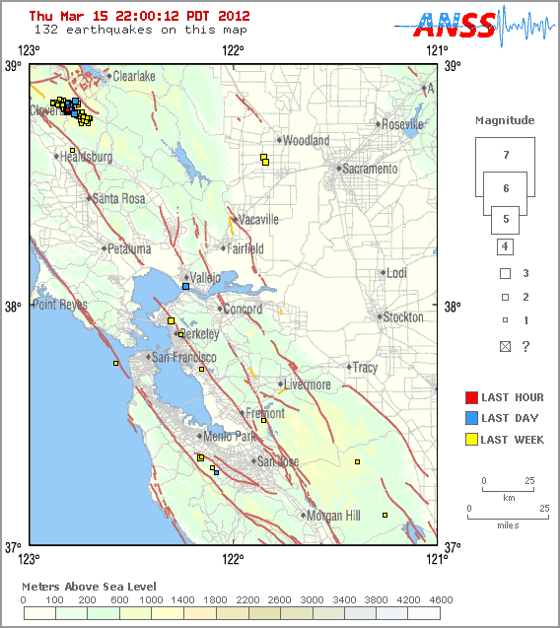

To see an inter-active earthquake fault map of the San Fransisco area, click this link:
http://earthquake.usgs.gov/earthquakes/recenteqscanv/FaultMaps/San_Francisco.html

